**SIR APOLLO**

**END OF TERM III EXAMINATION 2023**

**P.5 SOCIAL STUDIES & RE**

***Time Allowed: 2hours 15 Minutes***

**Pupil’s Name: …………………….……………………………………**

**Class: ………………………………….……………………………………**

**School Name: ………………………………….……………………….**

|  |  |  |
| --- | --- | --- |
| **FOR EXAMINERS’**  USE ONLY | | |
| **Qn. No.** | **MARKS** | **EXR’S**  **No.** |
| **1 - 10** |  |  |
| **11 – 20** |  |  |
| **21 – 30** |  |  |
| **31 – 40** |  |  |
| **41 – 43** |  |  |
| **44 – 46** |  |  |
| **47 – 49** |  |  |
| **50 - 52** |  |  |
| **53 - 55** |  |  |
| **TOTAL** |  |  |

**Read the following instructions carefully:**

1. This paper has two sections: **A** and **B**
2. Section **A** has 40 questions (40 marks)
3. Section **B** has 15 questions (50 marks)
4. Answer all questions. All the working for both sections A and B must be shown in the spaces provided.
5. All working must be done using a blue or blackball point pen or ink. Any work done in pencil will NOT be marked except drawings and diagram.
6. Unnecessary changes in your work and handwriting that cannot be easily read may lead to loss of marks.
7. Do not fill anything in the table indicated

**“For examiners’ use only”** and the boxes inside the question paper

**Turn Over**

**SECTION A (40 MARKS)**

1. Why are symbols used on a map instead of real objects?

_________________________________________________________________________

1. Draw a picture of a circular table.

_________________________________________________________________________

1. Write LEGCo in full.

_________________________________________________________________________

1. Give the opposite direction to where the sun rises.

_________________________________________________________________________

1. Which natural vegetation covers most parts of Uganda?

_________________________________________________________________________

1. How are road signs important to the people using roads?
2. _________________________________________________________________________
3. Why did the British use indirect rule in most parts of Uganda?

_________________________________________________________________________

1. Name any one lake shared by Uganda and DRC.

_________________________________________________________________________

1. Why do farmers in Kisoro terrace their land?

_________________________________________________________________________

1. Mention any one elected leader in a district.

_________________________________________________________________________

1. Name the British official who declared Uganda a British Protectorate in 1894.

_________________________________________________________________________

1. Give the importance of longitude and latitudes to a map reader.

_________________________________________________________________________

1. How is order kept in school?

_________________________________________________________________________

1. Which sea port handles most of Uganda’s imports and exports?

_________________________________________________________________________

1. Mention the best season for planting crops.

_________________________________________________________________________

1. What economic activity takes place at a supermarket?

_________________________________________________________________________

1. Why do people in Kapchorwa district rear donkeys?

_________________________________________________________________________

1. State any one positive effect of the coming of the Arabs to Uganda.

_________________________________________________________________________

1. From which direction did the River-Lake Nilotes enter Uganda?

_________________________________________________________________________

1. Apart from Mt. Rwenzori, name another physical feature which was formed through the means of faulting in Uganda.

_________________________________________________________________________

1. Give one legend told by the people of Acholi to their younger ones.

_________________________________________________________________________

1. Give the reason why the Greenwich Meridian is called so.

_________________________________________________________________________

1. Mention the main use of a rain gauge at a weather station.

_________________________________________________________________________

1. By what method did the early man obtain food?

_________________________________________________________________________

1. What is rural-urban migration?

_________________________________________________________________________

1. State any one reason why R. Nile is not navigable in some parts.

_________________________________________________________________________

1. Give one reason why many people in your area use road transport.

_________________________________________________________________________

1. Who is a citizen?

_________________________________________________________________________

1. How has UWESO tried to help orphans in Uganda?

_________________________________________________________________________

1. Write NEMA in full. _____________________________________________________
2. Name the type of rainfall received around Mabira forest.

_________________________________________________________________________

1. Who heads Legislature in Uganda?

_________________________________________________________________________

1. Why was Egypt interested in colonizing Uganda?

_________________________________________________________________________

1. Give any one natural resource to man.

_________________________________________________________________________

1. Mention any one product got from cotton.

_________________________________________________________________________

**For question 36 – 40, answer Either Christianity Or Islam but not both on a number**

1. **Either:** Why were the Jews against Jesus?

________________________________________________________________

**Or:** Why were the pagans of Mecca against Prophet Mohammed?

________________________________________________________________

1. **Either:** According to Christianity, what is voluntary work?

________________________________________________________________

**Or:** According to Islam, what is voluntary work?

________________________________________________________________

1. **Either:** Name any one Christian public holiday in Uganda.

________________________________________________________________

**Or:** Name any one Islamic public holiday in Uganda.

________________________________________________________________

1. **Either:** What is a prayer?

________________________________________________________________

**Or:** What is salat (Prayer)?

________________________________________________________________

**SECTION B (60 MARKS)**

1. 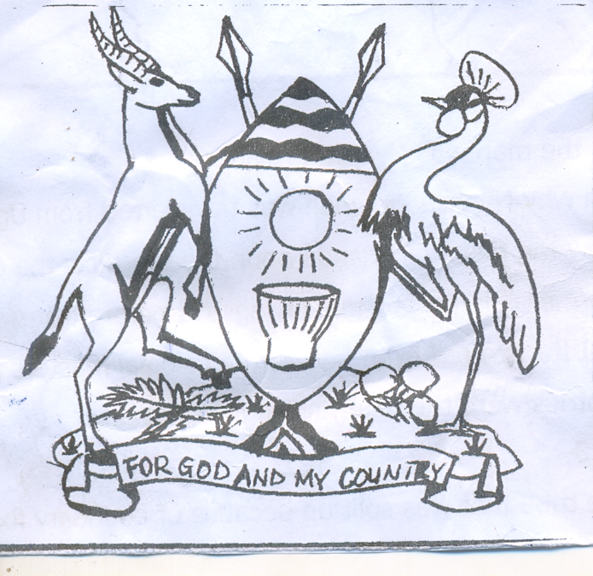 **Use the diagram below to answer the questions that follow.**
2. Name the above symbol of a nation.

______________________________________________________________________

1. Who designed the above symbol of a nation?

______________________________________________________________________

1. What does the Kob represent?

______________________________________________________________________

1. Apart from the above symbol of a nation in (a), give any other symbol of a nation which stands for unity.

______________________________________________________________________

1. a) Name the body that sent most European explorers to Uganda.

_________________________________________________________________________

b) Mention the Kabaka of Buganda who welcomed the first explorers in Buganda.

________________________________________________________________________

c) State any two problems faced by the European explorers in Uganda.

i) _______________________________________________________________________

ii) ______________________________________________________________________

1. a) Give the meaning of subsistence farming.

_________________________________________________________________________

b) Why do most Ugandans practice the above type of farming?

_________________________________________________________________________

c) State any two problems facing crop farmers in Uganda.

i) _______________________________________________________________________

ii) ______________________________________________________________________

1. a) Give any two examples of basic needs of man.

i) ___________________________________ ii) _____________________________

b) Write down any two ways how people get their basic needs.

i) _____________________________________________________________________

ii) _____________________________________________________________________

1. a) Write IBEACo in full.

_________________________________________________________________________

b) Name the British official who represented IBEACo in Uganda.

______________________________________________________________________

c) Why did IBEACo withdraw its activities from Uganda?

______________________________________________________________________

d) Give any one example of a British collaborator in Uganda.

______________________________________________________________________

1. 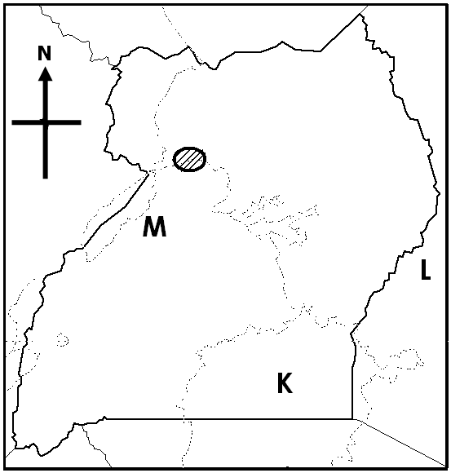**Study the sketch map of Uganda below and use it o answer questions that follow.**
2. In which direction is country marked with letter L from Uganda?

______________________________________________________________________

1. Name the game park found in the shaded area on the map.

______________________________________________________________________

1. Which mineral was discovered at the shores of lake marked with letter M?

______________________________________________________________________

1. Mention the European explorer who named lake marked with letter K its current name.

______________________________________________________________________

1. a) Give two aspects of climate.

(i) __________________________ (ii) __________________________

b) State any two factors that determine the climate of any given area.

(i) __________________________ (ii) __________________________

1. a) Apart from legislature, mention two other organs of a democratic government.

(i) __________________________ (ii) __________________________

b) Give any two duties of legislature.

(i) ________________________________________________________________

(ii) ________________________________________________________________

1. a) What are children’s rights?

______________________________________________________________________

b) Give any two examples of children’s rights.

(i) ________________________________________________________________

(ii) ________________________________________________________________

c) State any one way how children’s rights are violated.

______________________________________________________________________

1. a) How did the 1900 Buganda Agreement affect the land ownership of Buganda?

______________________________________________________________________

b) Why was Kabaka Daudi Chwa unable to sign the 1900 Buganda Agreement?

______________________________________________________________________

c) Name the British official who signed the above agreement on behalf of Britain.

______________________________________________________________________

d) Mention any one regent of Buganda during the signing of the 1900 Buganda Agreement.

______________________________________________________________________

**Answer Either Christianity Or Islam but not both.**

1. **Either:** a)What does the Holy Trinity mean?

**______________________________________________________________**

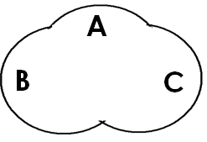**b)** Use the diagram below to name the three persons who make the Holy Trinity in their order.

1. A _____________________________________________________________
2. B ____________________________________________________________
3. C _____________________________________________________________

**Or:** Name the prophets who received the following Holy books;

1. Taura ______________________________ ii) Injir __________________________

iii ) Quran ______________________________ iv) Zabur ______________________

1. **Either: a)**Mention two ways in which Abraham showed his faith to God.
2. **___________________________________________________**
3. **___________________________________________________**

b)State the relationship of the following people to Abraham.

i)Sarah __________________________ ii) Isaac _______________

**Or:** a) State two ways in which Ibrahim showed his faith to Allah.

1. _______________________________________________________________
2. _______________________________________________________________

b)Give the relationship of the following people to Ibrahim.

i) Sarah __________________________ ii) Ismail ______________________

1. **Either:** a)Write down any two apostles of Jesus Christ.

i) ____________________________ ii) __________________________

b) How many apostles did Jesus have?

________________________________________________________________

c)Name the apostle who replaced Judas Iscariot.

_________________________________________________________________

**Or: a)**Name one of the first people to accept Prophet Mohammed’s teaching.

**__________________________________________________________**

b)Who is believed to be the founder of Islam?

______________________________________________________________________

c)Mention any two Caliphs of Prophet Mohammed.

i) ______________________________ ii) ___________________________________

1. **Either: a)**Give any two ways in which a Bible is a unique book.
2. ____________________________________________________________
3. ____________________________________________________________

b)In which two ways is the above book important to Christians?

_______________________________________________________________________

**Or: a)**Give any two ways in which a Quran is a unique book.

1. _____________________________________________________________
2. ______________________________________________________________
3. In which two ways is the above book important to Moslems?
4. ________________________________________________________________
5. ________________________________________________________________
6. **For Both:**
7. Give any two activities Jesus/Prophet Mohammed did as a child.
8. ________________________________________________________________
9. ________________________________________________________________
10. Mention any two activities (work) you do at home as a child.
11. ____________________________________________________________
12. _____________________________________________________________

**END**